**Activity: Terms and Conditions**

Not much of an Activity. It simply displays the terms and conditions from a .xml file within the project’s values folder. It can be accessed from the navigation bar, and on the Registration Activity.

**Manifest Details**

This activity is implemented by TermsAndConditions.java in the android Manifest. Its screenOrientation is set to “portrait,” and it uses the Default Intent Filter.

**Layout File(s)**

Activity_terms_and_conditions.xml

* The sole layout. It contains a single TextView, stored within a Scrolling Layout.

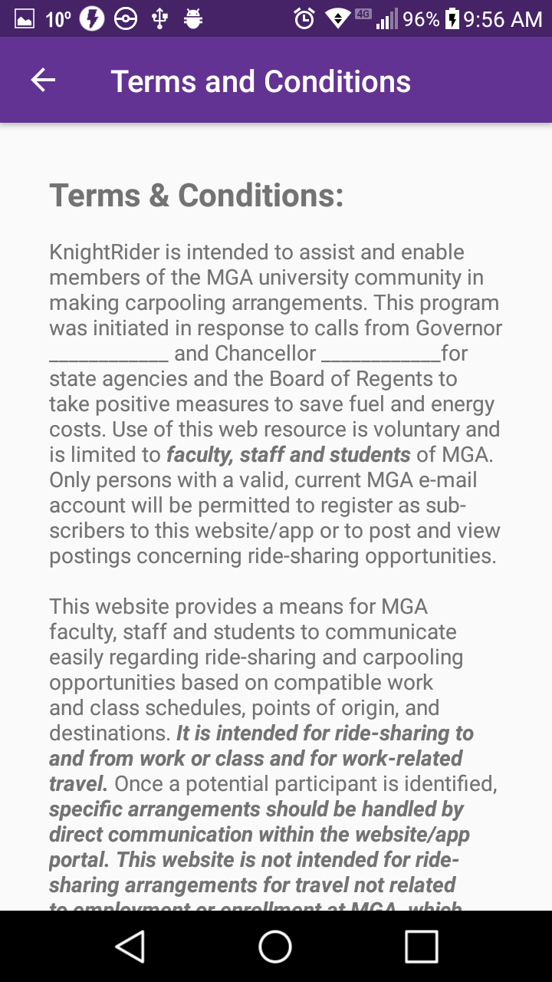

**Class File(s)**

TermsAndConditions.java

* Pulls the term’s document from an .xml in the values folder.
* Variables
  + This Activity has no variables.
* Methods
  + *onCreate(savedInstanceState): void
    - Dispalys the activity_terms_and_conditions layout
    - Creates a back Button in the toolbar
    - Finds the textView in the layout, and sets its text to an HTML Formated string pulled from the terms_and_conditions.xml file.
  + +onOptionsItemSelected(item): boolean
    - Return to the previous screen when the back button is tapped.

**Other File(s)**

Terms_and_conditions.xml

* Contains a string named “terms,” and holds the entire Terms and Conditions document, underneath a ![CDATA[]] tag for HTML formatting.